B. Sreenath Reddy

**Adult Census Income Project**

Wireframe documentation

1.The First page displays the pop up window where the user has to provide specific details such as Gender, Education, Bill payments etc.

All the information will be used to predict the result

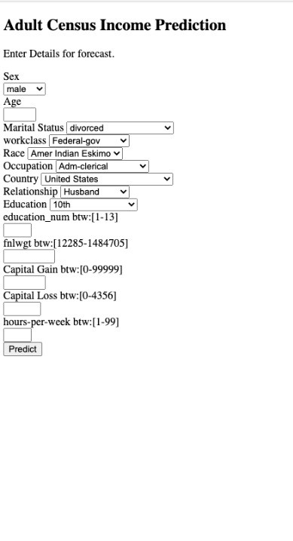

2. Incase you miss out one input the web page will alert you

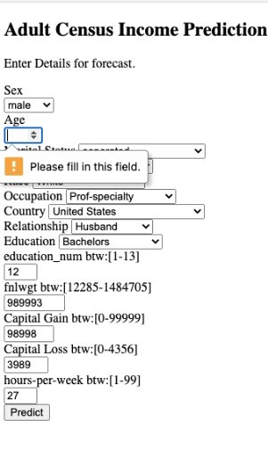

3.After entering necessary data we will get the prediction bottom of the page. Whether person default or not

